Multiprocessing vs Multithreading Difference

Multiprocessing and Multithreading both adds performance to the system.

**Multiprocessing** is adding more number of or CPUs/processors to the system which increases the computing speed of the system.

**Multithreading** is allowing a process to create more threads which increase the responsiveness of the system.

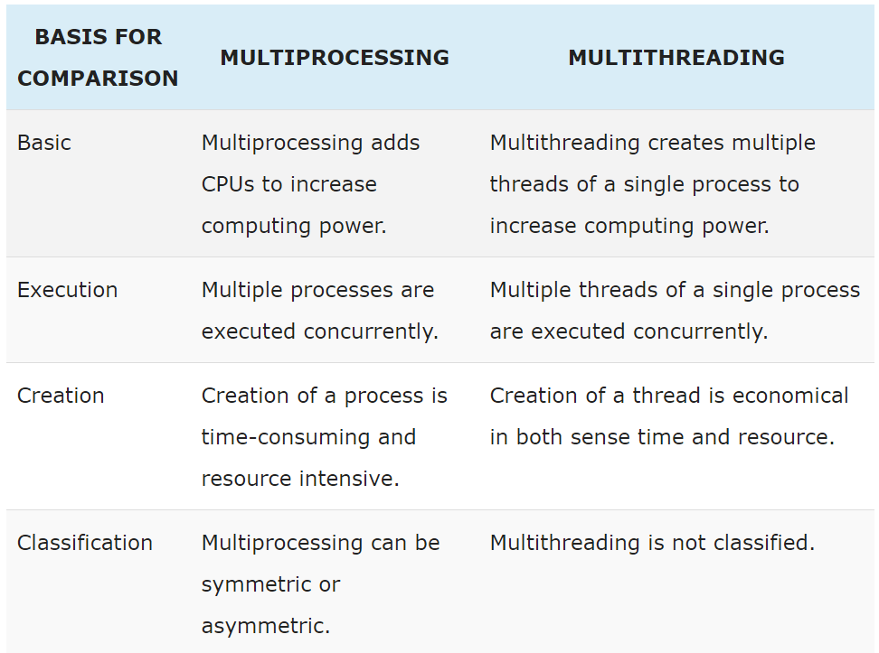

Definition of Multiprocessing

A multiprocessing system is one which has more than two processors. The CPUs are added to the system to increase the computing speed of the system. Each CPU has its own set of registers and main memory. Just because CPUs are separate, it may happen that one CPU must not have anything to process and may sit idle and the other may be overloaded with the processes. In such cases, the processes and the resources are shared dynamically among the processors.

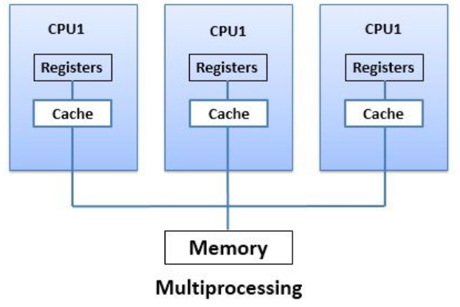

Multiprocessing can be classified as **symmetric multiprocessing** and **asymmetric multiprocessing**. In symmetric multiprocessing, all processors are free to run any process in a system. In Asymmetric multiprocessing, there is a master-slave relationship among the processors. The master processor is responsible for allotting the process to slave processors.

If the processor has **integrated memory controller** then adding processor would increase the amount of addressable memory in the system. Multiprocessing can change the memory access model from**uniform memory access** to **nonuniform memory access**. The uniform memory access amounts the same time for accessing any RAM from any Processor. On the other hands, non-uniform memory access amounts longer time to access some part of memory than the other parts.

### Definition of Multithreading

Multithreading is the execution of multiple threads of a single process concurrently within the context of that process. Now let us first discuss what is a thread? A **thread** of a process means a code segment of a process, which has its own thread ID, program counter, registers and stack and can execute independently. But threads belonging to the same process has to share the belongings of that process like code, data, and system resources. Creating separate processes for each service request consumes time and exhaust system resources. Instead of incurring this overhead, it is more efficient to create threads of a process.

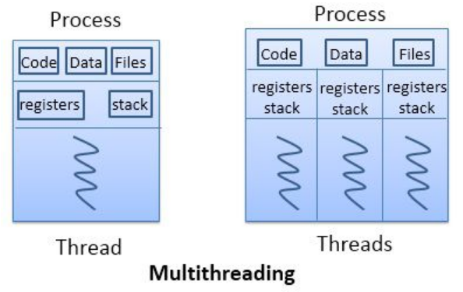

To understand the multithreading concept let us take an **example** of a word processor. A word processor, displays graphic, responds to keystrokes, and at the same time, it continues spelling and grammar checking. You do not have to open different word processors to do this concurrently. It does get happen in a single word processor with the help of multiple threads.

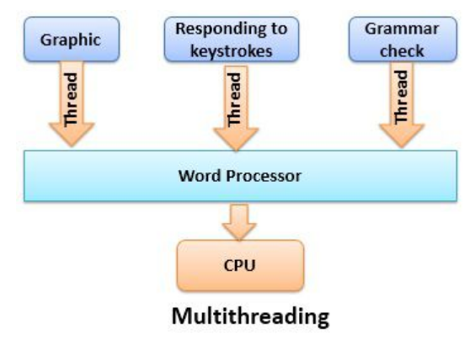

Now let us take into consideration the benefits of multithreading. Multithreading increases the **responsiveness** as if one thread of a process is blocked or performing the lengthy operation, the process still continues. The second benefit of multithreading is **resource sharing** as several threads of a process share same code and data within the same address space.

Creating a thread is **economical** as it shares the code and data of the process to which they belong. So the system does not have to allocate resources separately for each thread. Multithreading can be **increased** on multiprocessing operating system. As multithreading on multiple CPUs increases **parallelism**.

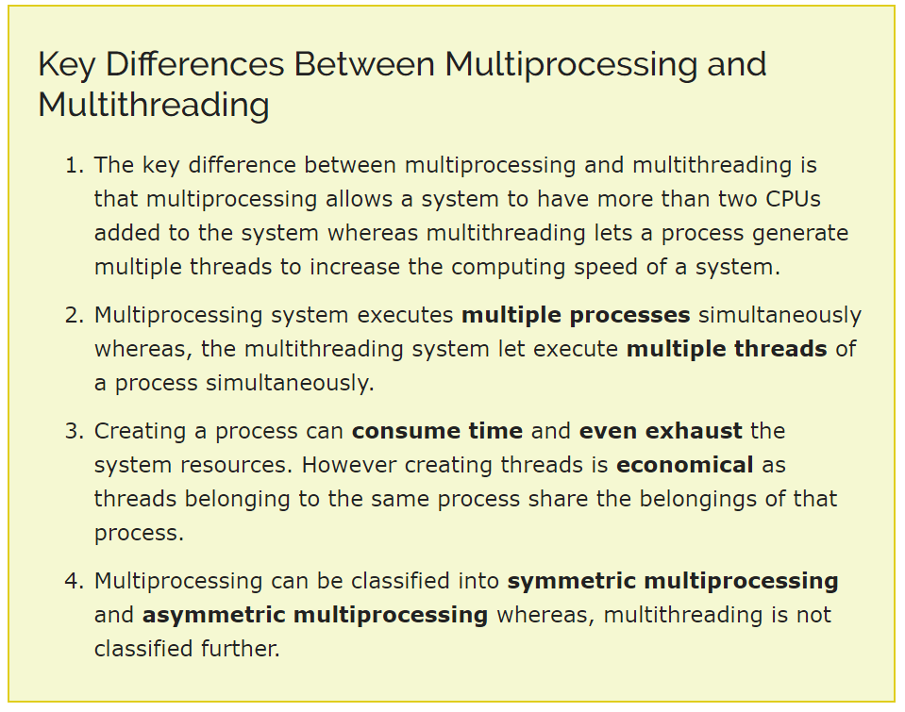

### Conclusion:

The benefits of multithreading can be gradually increased in multiprocessing environment as multithreading on a multiprocessing system increases parallelism.